1. **Uses lstat call and struct stat to display file attributes**

**attributes.c**

#include <stdio.h>

#include <sys/stat.h> /* For struct stat */

#include <stdarg.h>

#include <stdlib.h>

#include <time.h>

void quit(char *message, int exit_status)

{

printf(" %s",message);

exit(exit_status);

}

void arg_check (long int args, long int argc, char *message, long int exit_status)

{

if (argc != args)

{

printf("%s", message);

exit(exit_status);

}

}

int main(long int argc, char **argv)

{

struct stat statbuf; /* We’ll use lstat to populate this */

arg_check(2, argc, "Single filename required\n", 1) ;

if(lstat(argv[1], &statbuf) == -1)

quit("Couldn’t stat file", 1);

printf("File: %s\n", argv[1]);

printf("Inode number: %ld \n", statbuf.st_ino);

printf("UID: %ld ", statbuf.st_uid);

printf("GID: %ld\n", statbuf.st_gid);

printf("Type and Permissions: %o\n",statbuf.st_mode);

printf("Number of links: %ld \n", statbuf.st_nlink);

printf("Size in bytes: %ld\n", statbuf.st_size);

printf("Blocks allocated: %ld\n", statbuf.st_blocks);

printf("Last Modification Time: %s", ctime(&statbuf.st_mtime));

printf("Last Access Time: %s\n", ctime(&statbuf.st_atime));

exit(0);

}

**Output:**

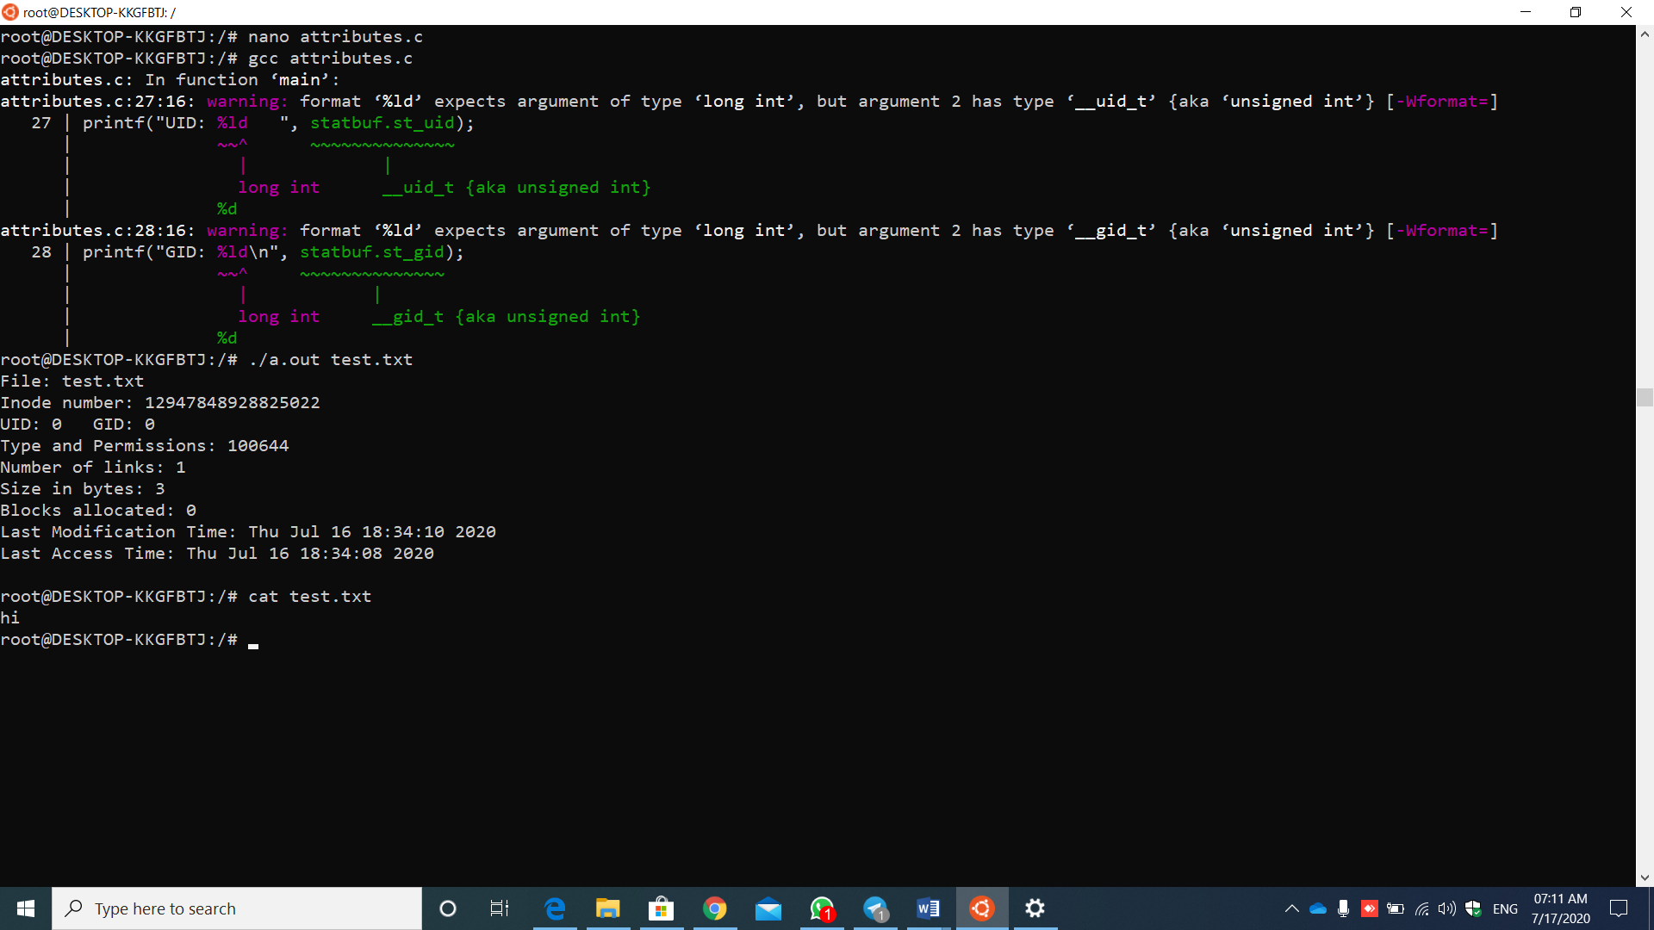

Steps:

1.create a file having c code in it

2.compile the file with gcc command

3.and execute the file ,here while executing the file we need to give one more file name which we created previously ,here(test.txt)

Eg: ./a.out test.txt

4.we get the final output.

References:

Complete information about stat - <https://pubs.opengroup.org/onlinepubs/009695399/functions/stat.html>

2. **Lists only directories - Uses S_IFMT and S_ISDIR macros**

lsdir.c

#include <sys/types.h>

#include <sys/stat.h>

#include <stdio.h>

#include <dirent.h>

#include <stdlib.h>

#include <unistd.h>

void quit (char *message, int exit_status)

{

printf(" %s",message);

exit(exit_status);

}

void arg_check(int args, int argc, char *message, int exit_status)

{

if(argc != args)

{

printf("%s", message);

exit(exit_status);

}

}

int main(int argc, char *argv[])

{

DIR *dir;

struct dirent *direntry; /* Returned by readdir() */

struct stat statbuf; /* Address of statbuf used by lstat() */

mode_t file_type,file_perm;

arg_check(2, argc, "Directory not specified\n", 1) ;

if((dir = opendir(argv[1])) == NULL)

quit("Couldn’t open directory", 1);

if((chdir(argv[1]) == -1)) /* Change to the directory before */

quit("chdir", 2); /* you starting reading its entries */

while((direntry = readdir(dir)) != NULL)

{

/* Read each entry in directory*/

if(lstat(direntry->d_name, &statbuf) < 0)

{

/* dname must be in */

perror("lstat");

/* current directory */

continue;

}

if(S_ISDIR(statbuf.st_mode))

{

/* If file is a directory */

file_type = statbuf.st_mode & S_IFMT;

file_perm = statbuf.st_mode & ~S_IFMT;

printf("%o %4o %s\n",file_type,file_perm,direntry->d_name);

}

}

exit(0);

}

Output:

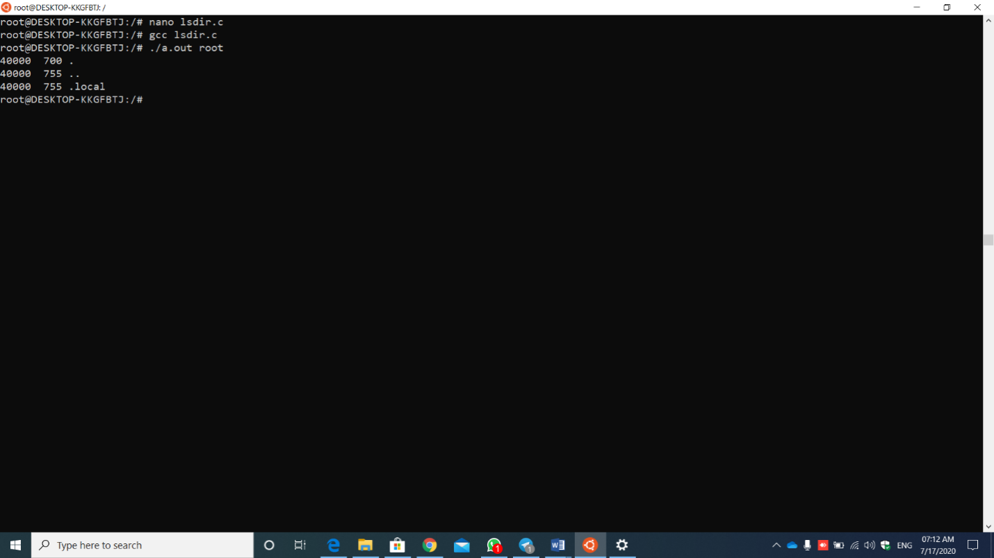

Steps:

1.create a file having c code in it.

2.now compile it using gcc command

3.as it is having command line arguments we need to give the directory over there. After writing the execution command, then we get the final output.

References:

<https://pubs.opengroup.org/onlinepubs/007908799/xsh/sysstat.h.html>

3. **change the group of the file.**

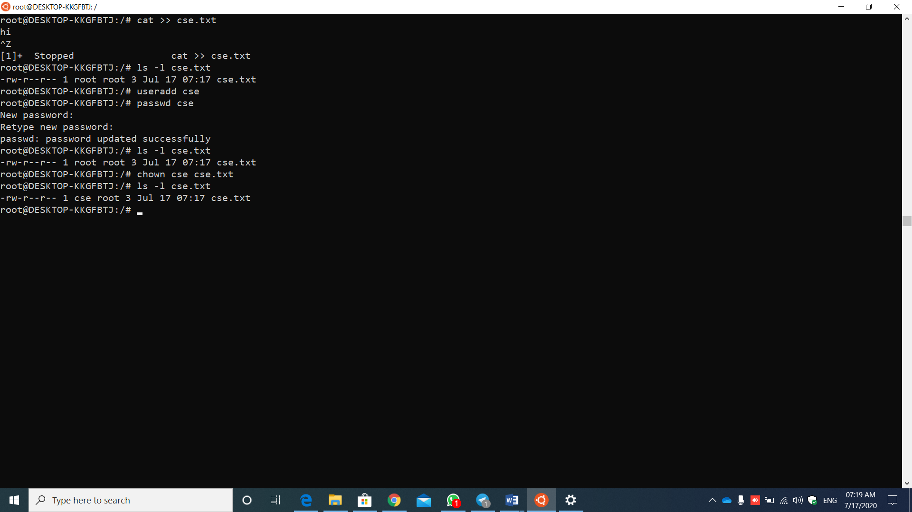

Steps:

As we are going to change the group of file we need to add a user , so we should come from home to the root directory in the terminal by pressing sudo su command.

1.create a file having some content in it.

2.check by using ls command .

3.now add a user

4.now add password for that user.

Now by using chown command change the group

5.once again check by using ls command

Finally the group will be changed.

References :

Chown command - <https://phoenixnap.com/kb/linux-chown-command-with-examples>

4. **changed the permission flags of the file.**

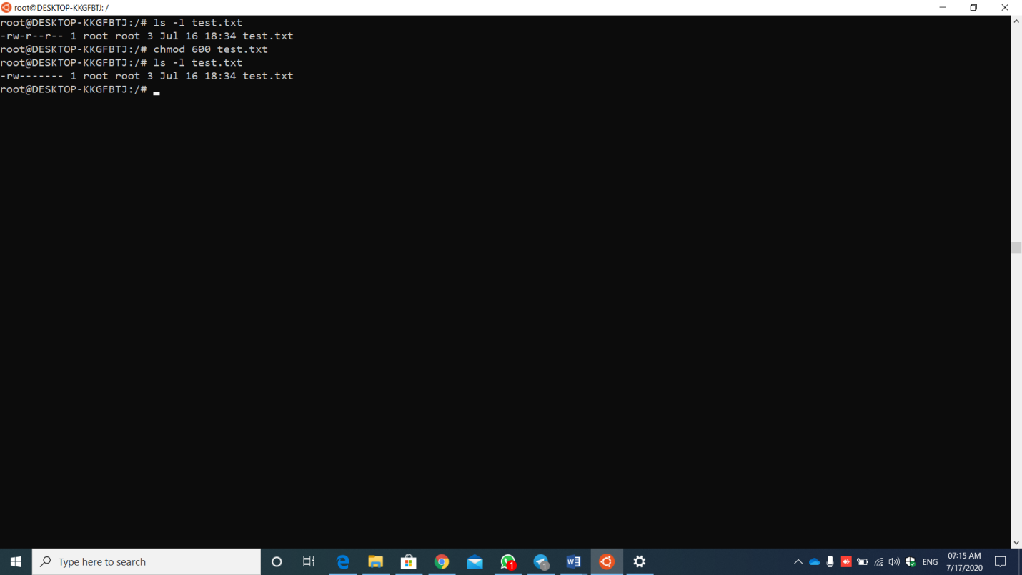

Steps:

1.create a file having some content in it.

2.now check all the permissions by using ls command

3. by using chmod command change the permissions of the file.

4.once check them whether the permissios are changed or not by using ls command .

References :

Chmod - [https://www.geeksforgeeks.org/chmod-command-linux/#:~:text=In%20Unix%2Dlike%20operating%20systems,an%20abbreviation%20of%20change%20mode.&text=Note%20%3A%20Putting%20blank%20space(s,removed%20from%20the%20specified%20classes.](https://www.geeksforgeeks.org/chmod-command-linux/" \l ":~:text=In Unix-like operating systems,an abbreviation of change mode.&text=Note : Putting blank space(s,removed from the specified classes.)